**Evidence Gathering Document for SQA Level 8 Professional Developer Award.**

This document is designed for you to present your screenshots and diagrams relevant to the PDA and to also give a short description of what you are showing to clarify understanding for the assessor.

Each point that required details the Assessment Criteria (What you have to show) along with a brief description of the kind of things you should be showing.

Please fill in each point with screenshot or diagram and description of what you are showing.

**Week 2**

| Unit | Ref | Evidence |  |
| --- | --- | --- | --- |
| I&T | I.T.5 | Demonstrate the use of an array in a program. Take screenshots of:  *An array in a program  *A function that uses the array  *The result of the function running | |
|  |  | **Description:** | |

**Paste Screenshot here**

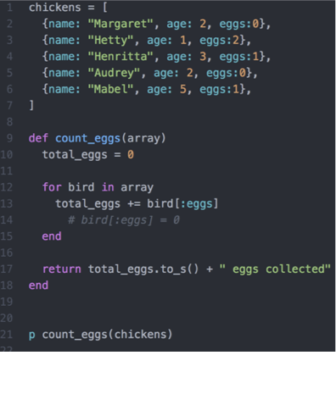

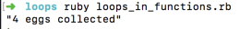

**Description here**

The function initializes a counter total_eggs and then loops through the array to add the eggs to the counter to find the total number of eggs within the array.

| Unit | Ref | Evidence |  |
| --- | --- | --- | --- |
| I&T | I.T.6 | Demonstrate the use of a hash in a program. Take screenshots of:  *A hash in a program  *A function that uses the hash  *The result of the function running | |
|  |  | **Description:** | |

**Paste Screenshot here**

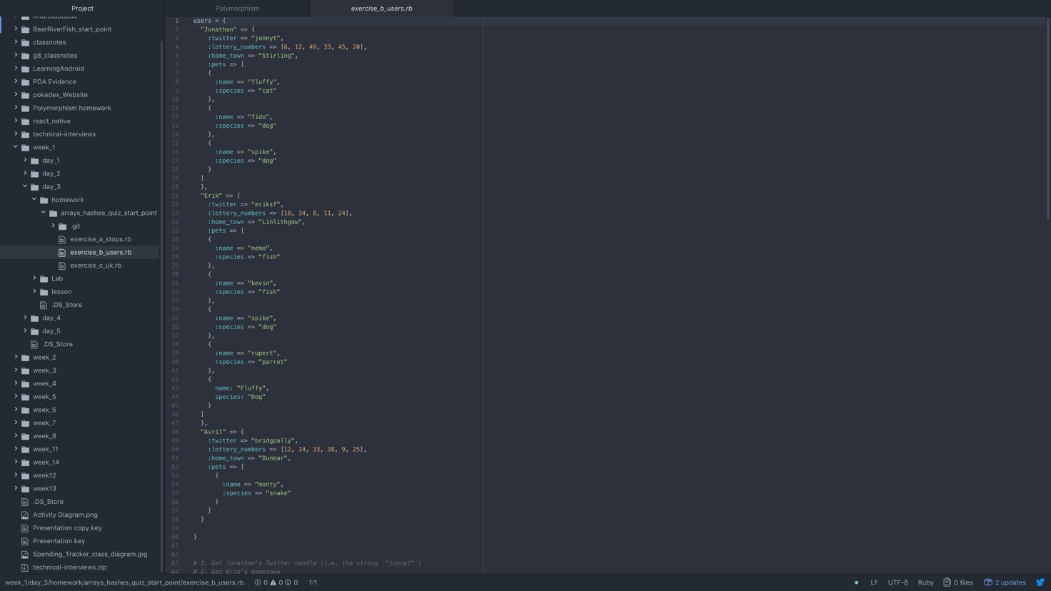

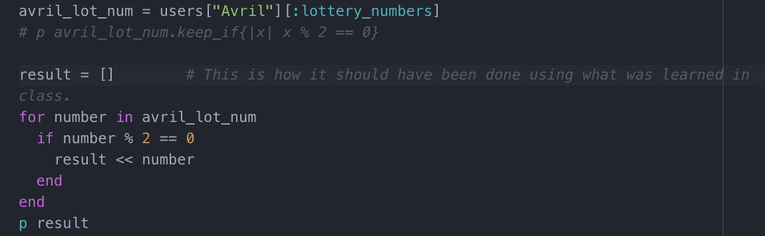

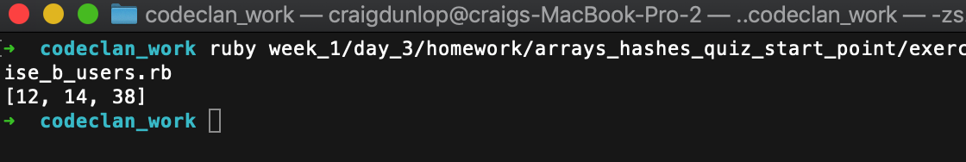

**Description here**

The function creates an empty array called result. It then loops through the array of lottery numbers and if it is an even number then it is added to the result array.

**Week 3**

| Unit | Ref | Evidence |  |
| --- | --- | --- | --- |
| I&T | I.T.3 | Demonstrate searching data in a program. Take screenshots of:  *Function that searches data  *The result of the function running | |
|  |  | **Description:** | |

**Paste Screenshot here**

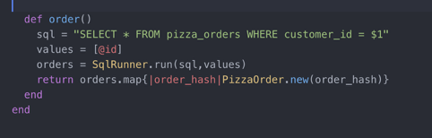

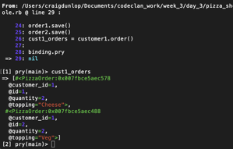

**Description here**

The function searches through the database for orders which have the same customer id being searched. it then returns an array of pizza’s.

| Unit | Ref | Evidence |  |
| --- | --- | --- | --- |
| I&T | I.T.4 | Demonstrate sorting data in a program. Take screenshots of:  *Function that sorts data  *The result of the function running | |
|  |  | **Description:** | |

**Paste Screenshot here**

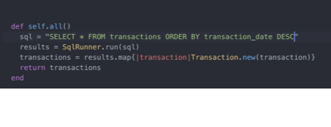

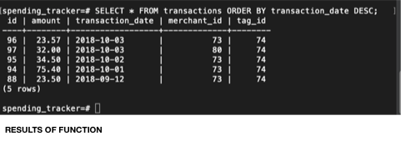

**Description here**

**Transactions are sorted by most recent order.**

**Week 5 and 6**

| Unit | Ref | Evidence |  |
| --- | --- | --- | --- |
| A&D | A.D.1 | A Use Case Diagram | |
|  |  | **Description:** | |

**Paste Screenshot here**

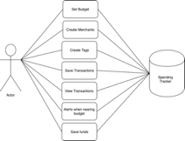

**Description here**

| Unit | Ref | Evidence |  |
| --- | --- | --- | --- |
| A&D | A.D.2 | A Class Diagram | |
|  |  | **Description:** | |

**Paste Screenshot here**

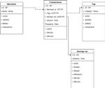

**Description here**

| Unit | Ref | Evidence |  |
| --- | --- | --- | --- |
| A&D | A.D.3 | An Object Diagram | |
|  |  | **Description:** | |

**Paste Screenshot here**

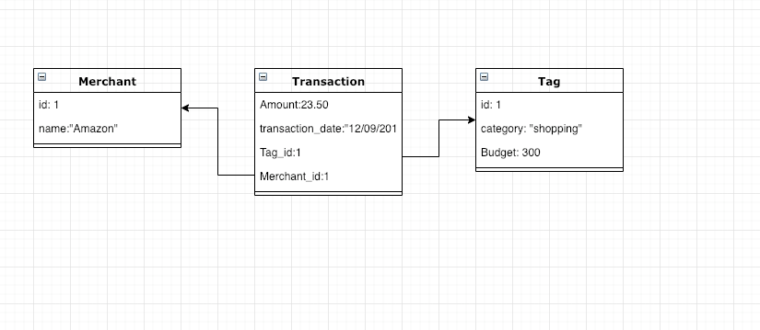

| Unit | Ref | Evidence |  |
| --- | --- | --- | --- |
| A&D | A.D.4 | An Activity Diagram | |
|  |  | **Description:** | |

**Paste Screenshot here**

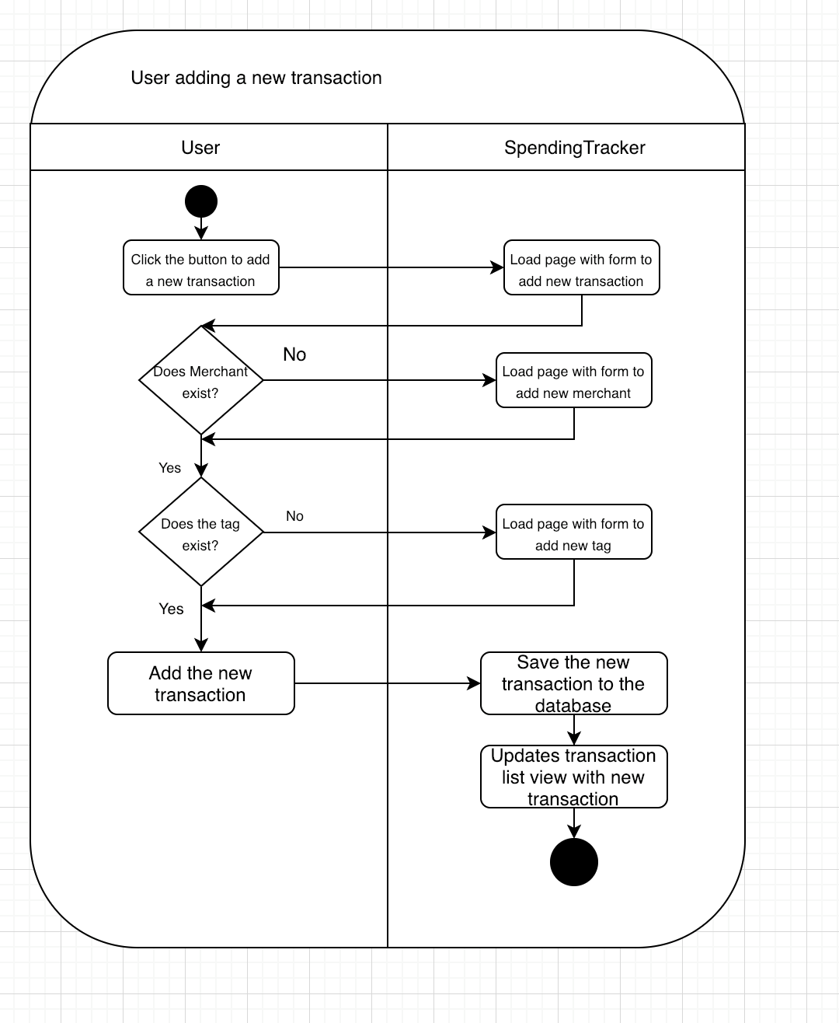

**Description here**

| Unit | Ref | Evidence |  |
| --- | --- | --- | --- |
| A&D | A.D.6 | Produce an Implementations Constraints plan detailing the following factors:  *Hardware and software platforms  *Performance requirements  *Persistent storage and transactions  *Usability  *Budgets  *Time | |
|  |  | **Description:** | |

**Paste Screenshot here**

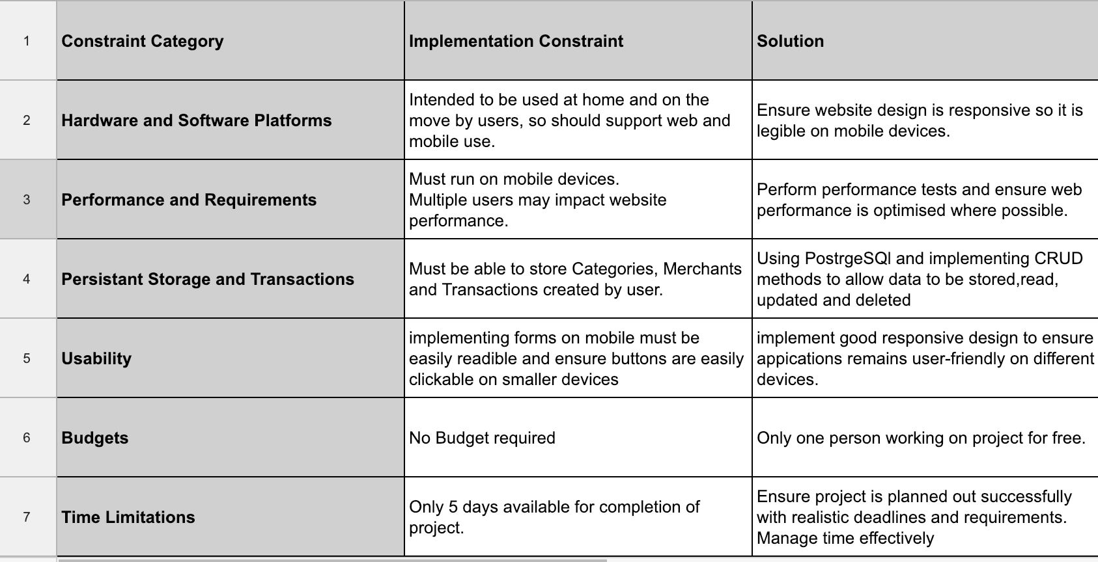

**Description here**

| Unit | Ref | Evidence |  |
| --- | --- | --- | --- |
| P | P.5 | User Site Map | |
|  |  | **Description:** | |

**Paste Screenshot here**

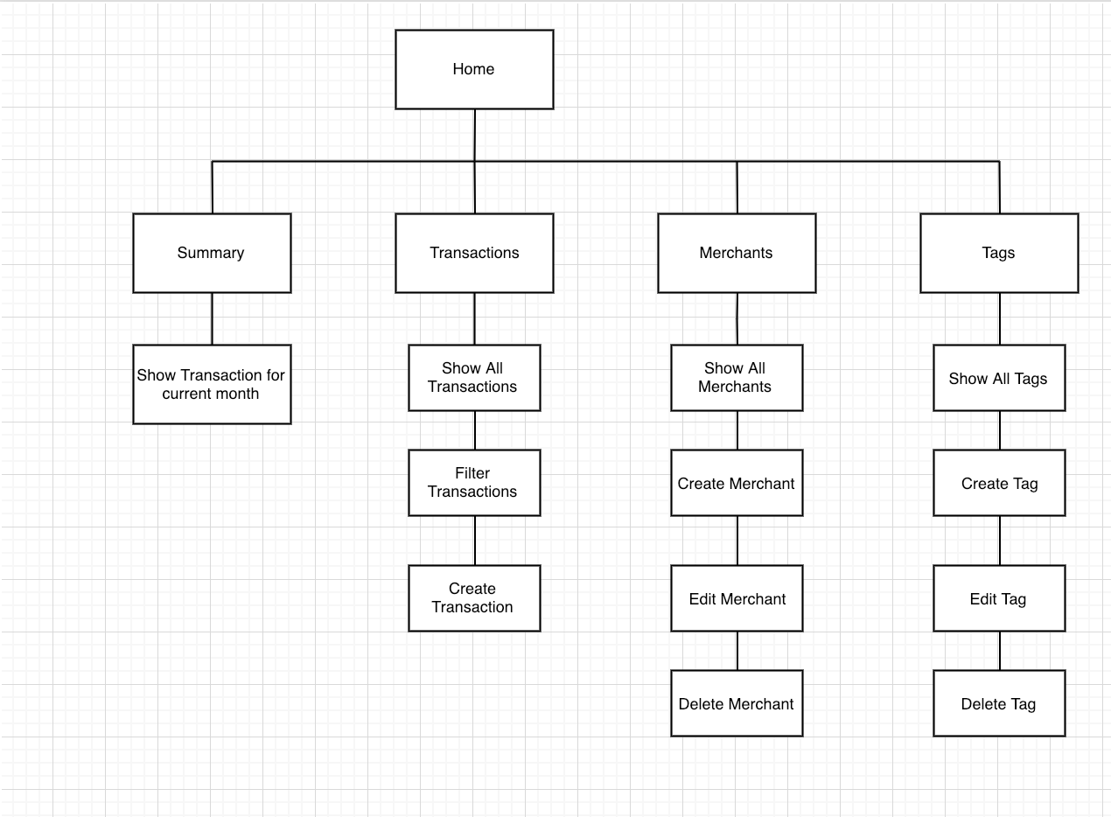

| Unit | Ref | Evidence |  |
| --- | --- | --- | --- |
| P | P.6 | 2 Wireframe Diagrams | |
|  |  | **Description:** | |

**Paste Screenshot here**

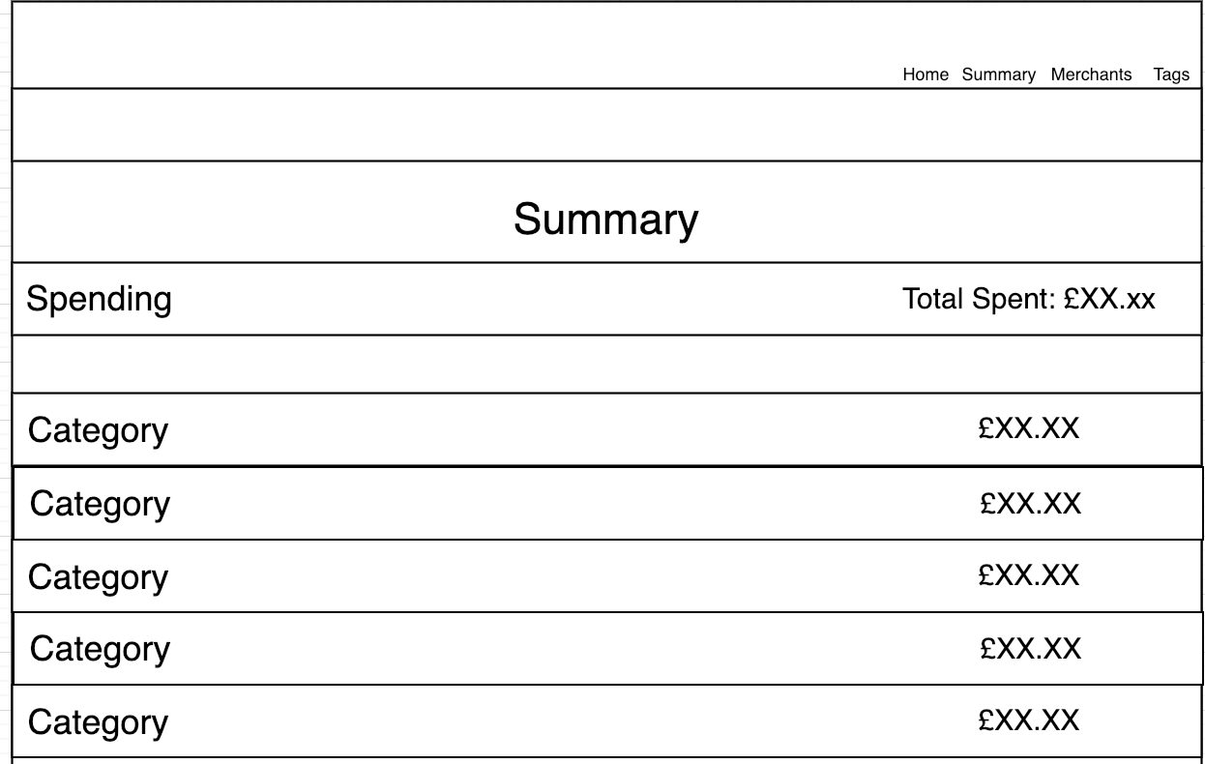

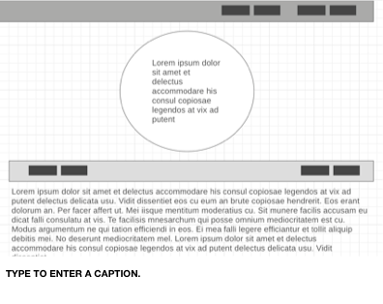

**Description here**

| Unit | Ref | Evidence |  |
| --- | --- | --- | --- |
| P | P.10 | Example of Pseudocode used for a method | |
|  |  | **Description:** | |

**Paste Screenshot here**

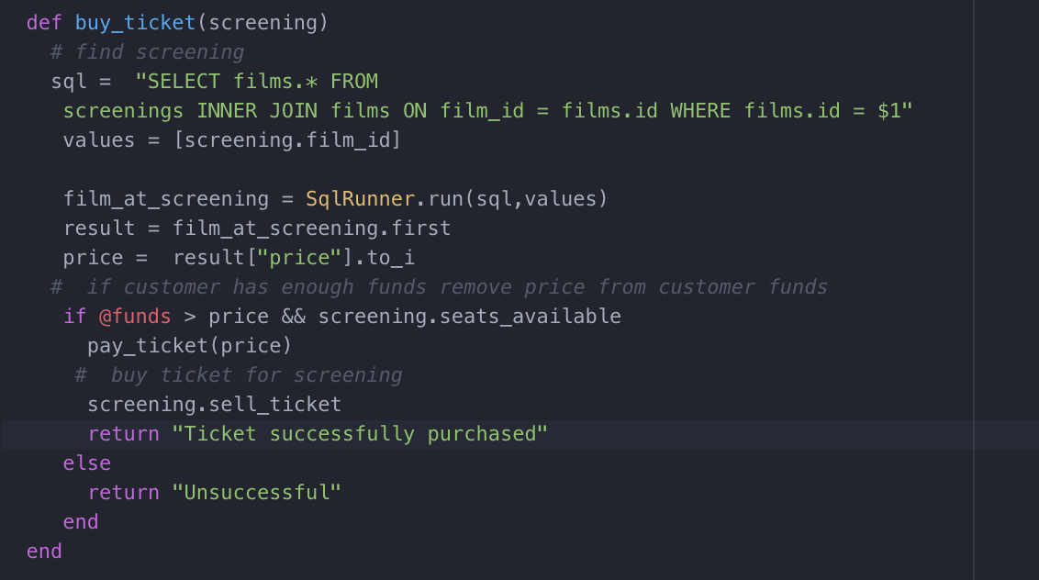

**Description here**

| Unit | Ref | Evidence |  |
| --- | --- | --- | --- |
| P | P.13 | Show user input being processed according to design requirements. Take a screenshot of:  * The user inputting something into your program  * The user input being saved or used in some way | |
|  |  | **Description:** | |

**Paste Screenshot here**

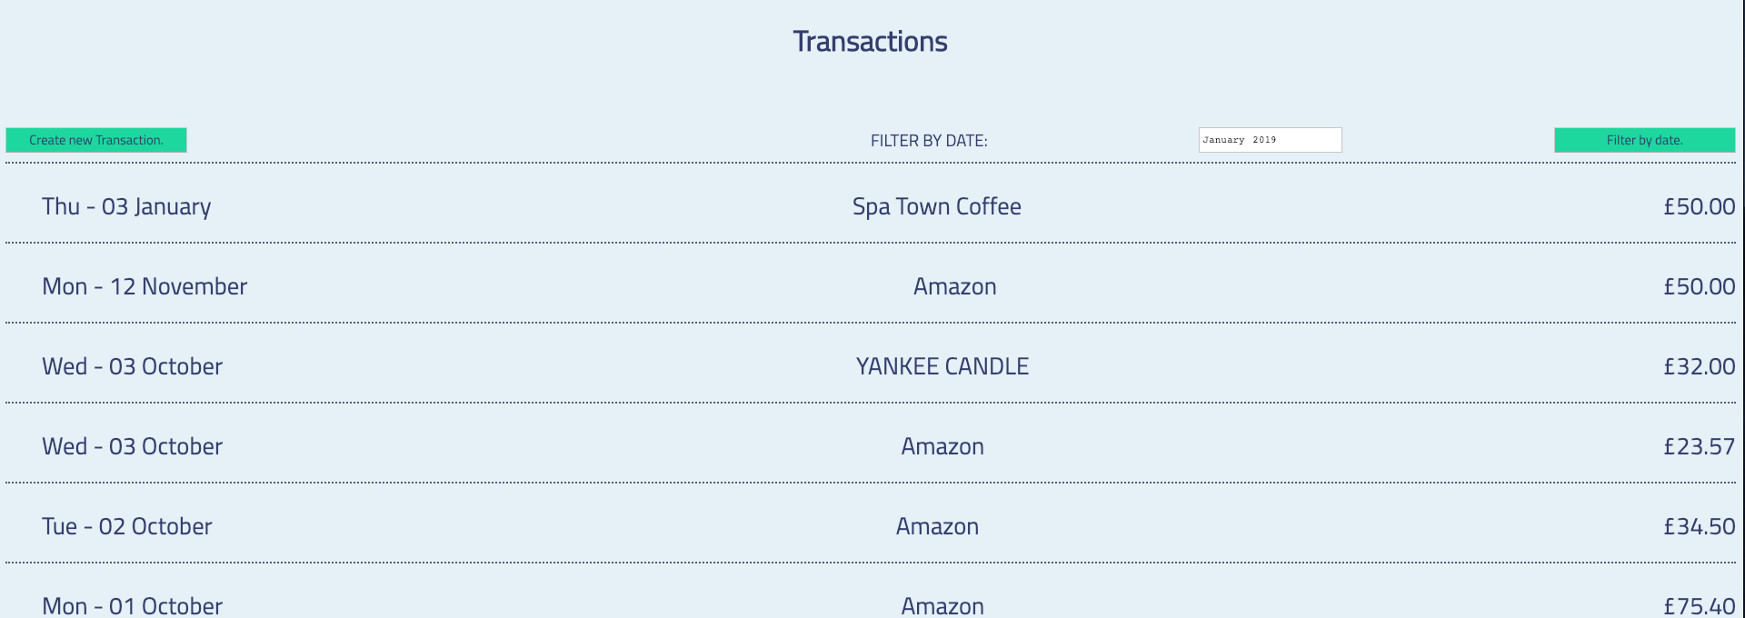

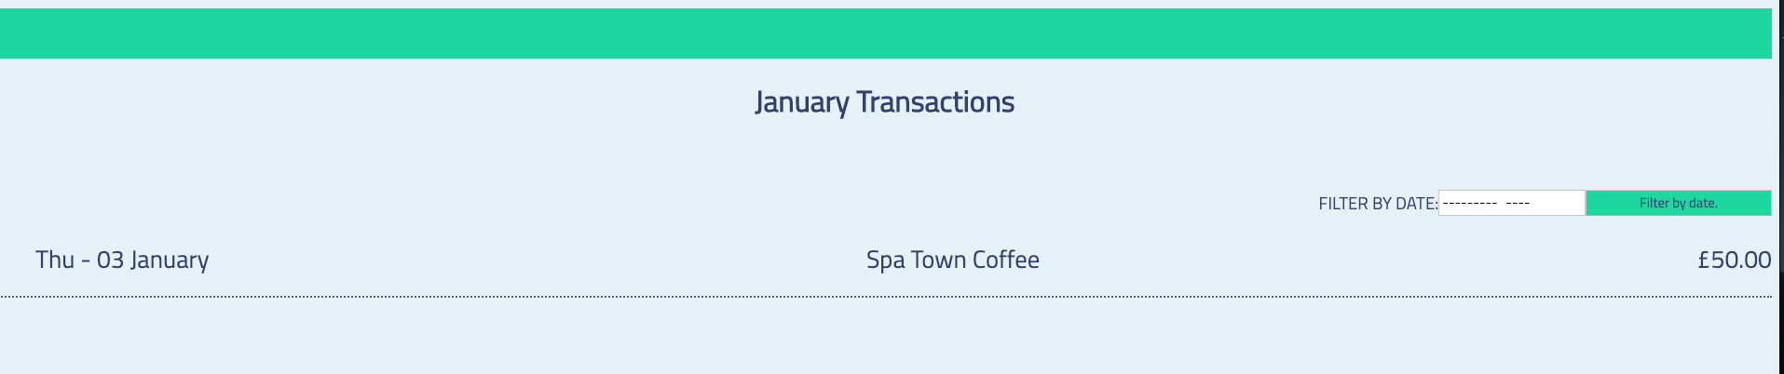

**Description here**

**The user inputs a date which then brings back the transactions for that given date.**

| Unit | Ref | Evidence |  |
| --- | --- | --- | --- |
| P | P.14 | Show an interaction with data persistence. Take a screenshot of:  * Data being inputted into your program  * Confirmation of the data being saved | |
|  |  | **Description:** | |

**Paste Screenshot here**

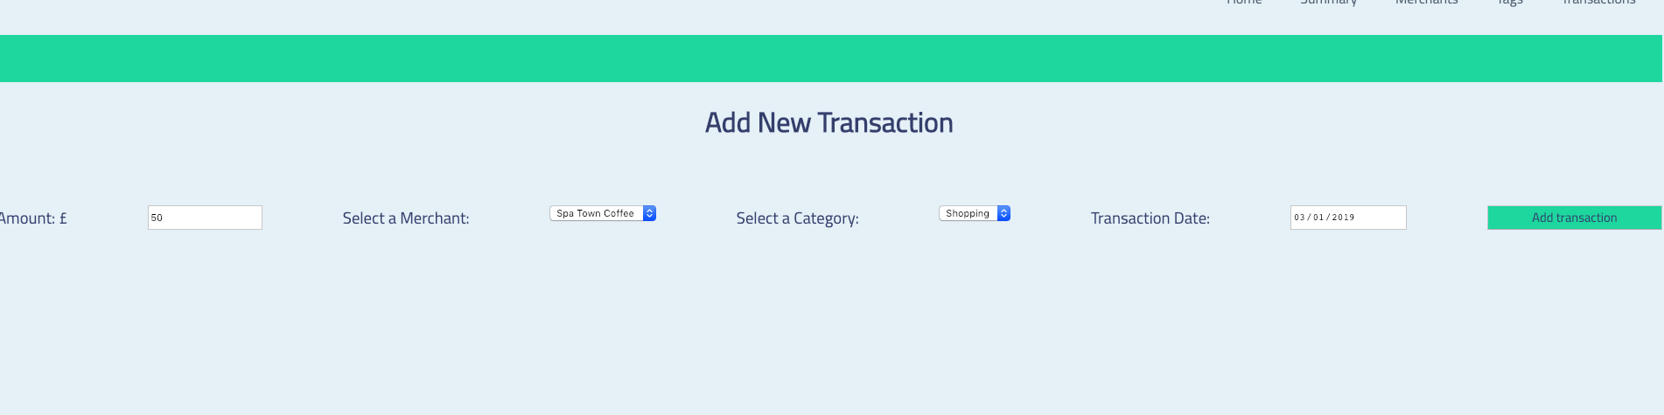

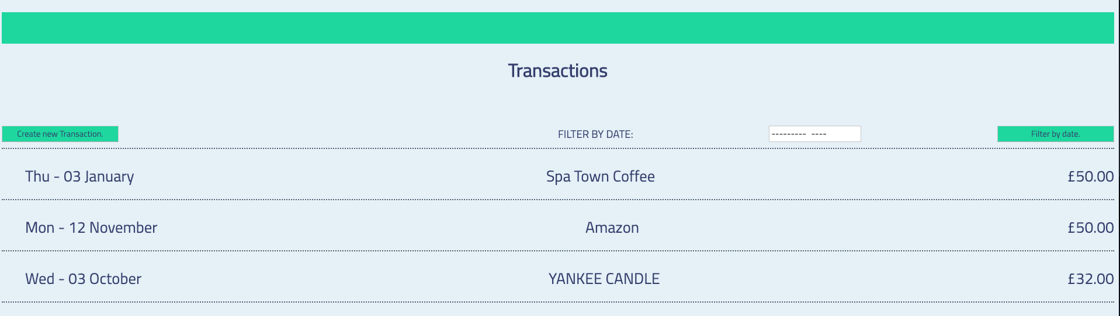

**Description here**

User inputs a transactions amount with a merchant category and transaction date. This is then saved to the databased and will be rendered when the transactions page is viewed.

| Unit | Ref | Evidence |  |
| --- | --- | --- | --- |
| P | P.15 | Show the correct output of results and feedback to user. Take a screenshot of:  * The user requesting information or an action to be performed  * The user request being processed correctly and demonstrated in the program | |
|  |  | **Description:** | |

**Paste Screenshot here**





**Description here**

The user inputs a month/year they would like to filter transactions by and press the filter by date button which will then bring back a new view with all the transactions within that month/year.

| Unit | Ref | Evidence |  |
| --- | --- | --- | --- |
| P | P.11 | Take a screenshot of one of your projects where you have worked alone and attach the Github link. | |
|  |  | **Description:** | |

**Paste Screenshot here**

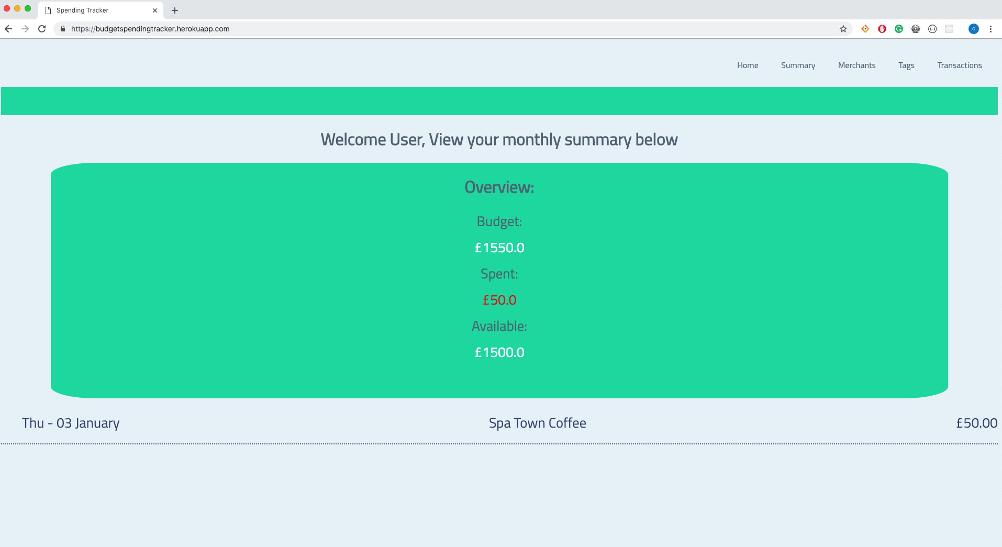

**Description here**

**https://github.com/cd9393/Week5_Spending_Tracker**

| Unit | Ref | Evidence |  |
| --- | --- | --- | --- |
| P | P.12 | Take screenshots or photos of your planning and the different stages of development to show changes. | |
|  |  | **Description:** | |

**Paste Screenshot here**

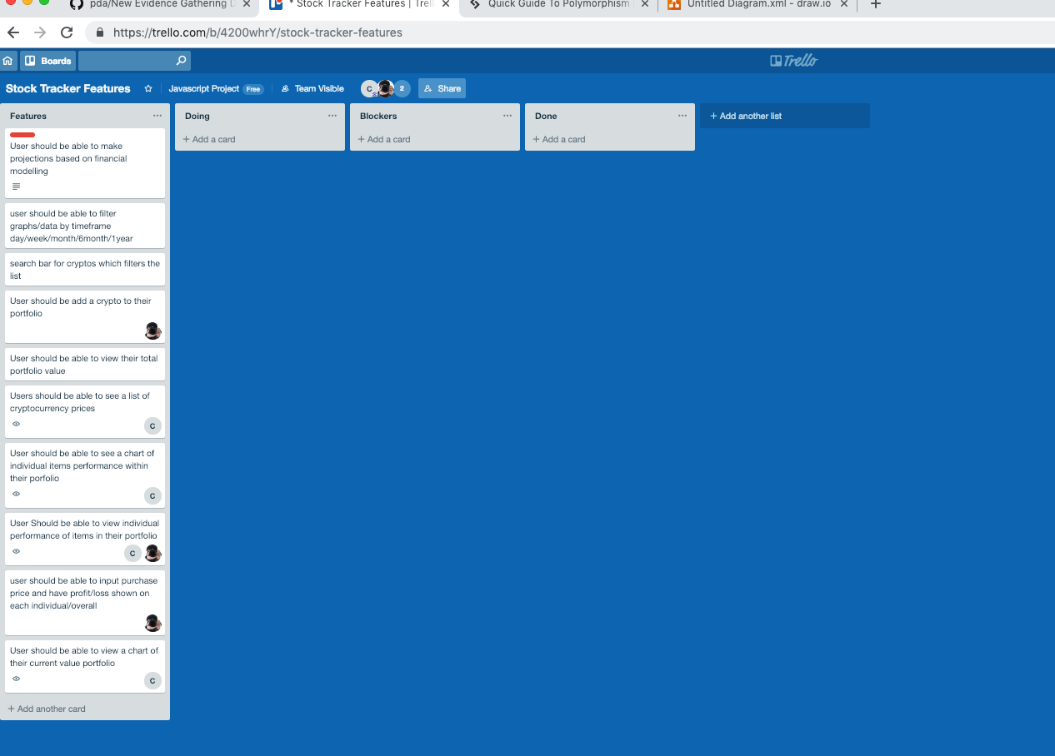

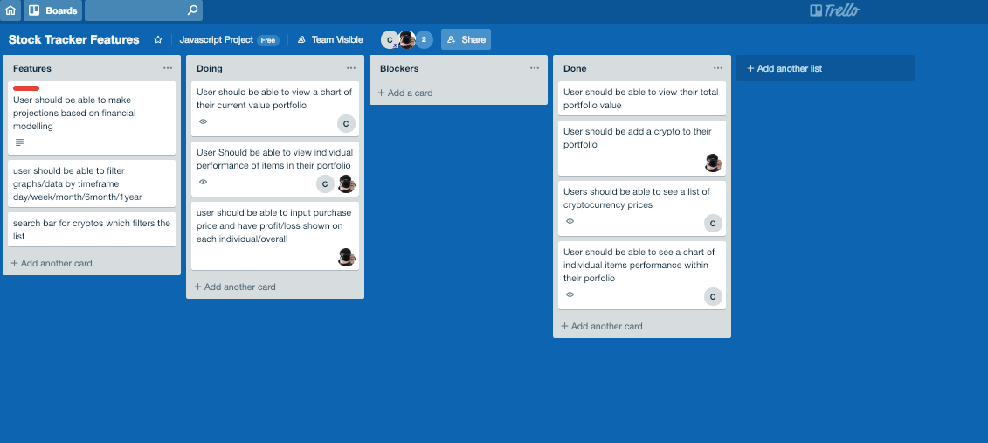

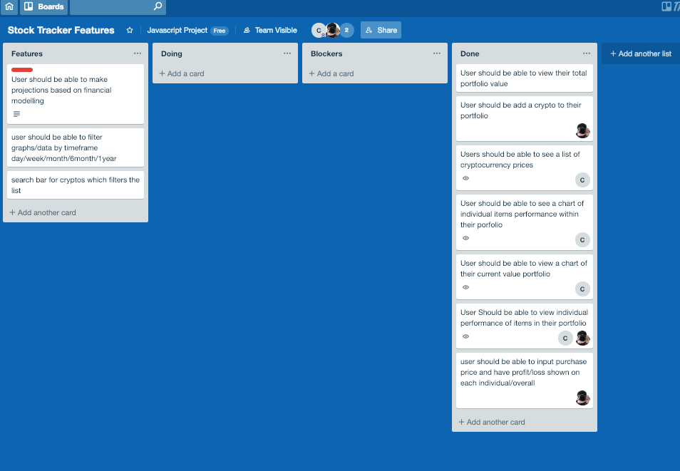

**Description here**

**Week 7**

| Unit | Ref | Evidence |  |
| --- | --- | --- | --- |
| P | P.16 | Show an API being used within your program. Take a screenshot of:  * The code that uses or implements the API  * The API being used by the program whilst running | |
|  |  | **Description:** | |

**Paste Screenshot here**

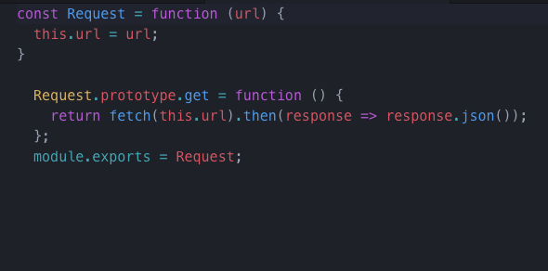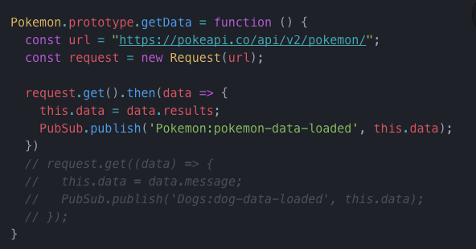

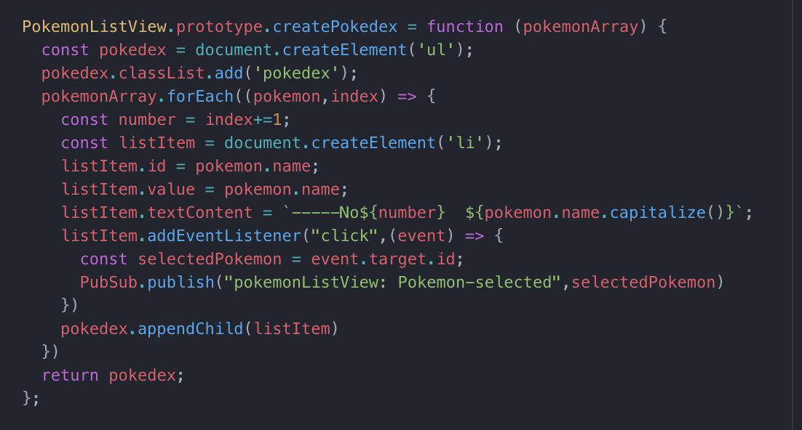

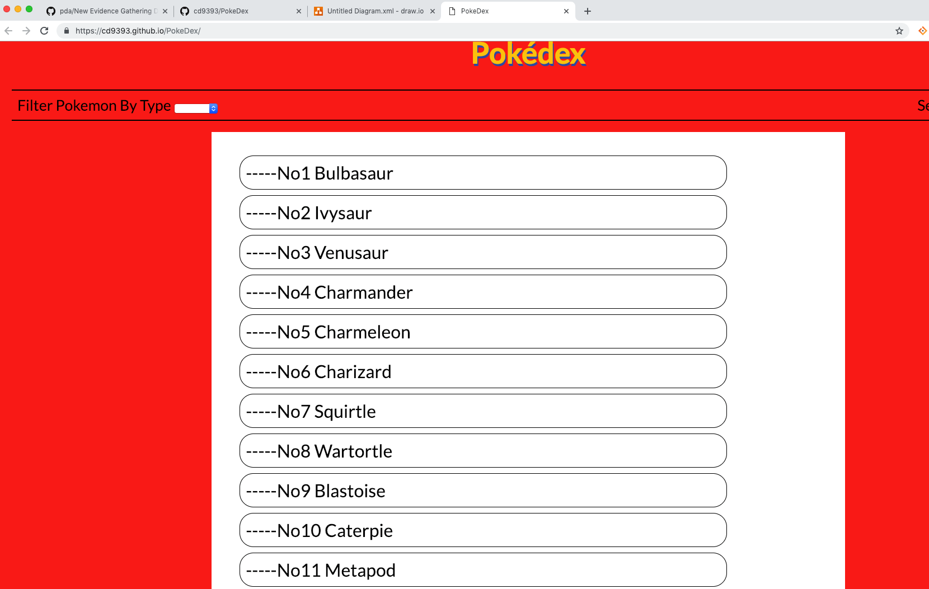

**Description here**

An API request is made to get all the pokemon information from the API. This is then published out using PubSub to the views page which then creates the list of pokemon as shown above.

| Unit | Ref | Evidence |  |
| --- | --- | --- | --- |
| P | P.18 | Demonstrate testing in your program. Take screenshots of:  * Example of test code  * The test code failing to pass  * Example of the test code once errors have been corrected  * The test code passing | |
|  |  | **Description:** | |

**Paste Screenshot here**

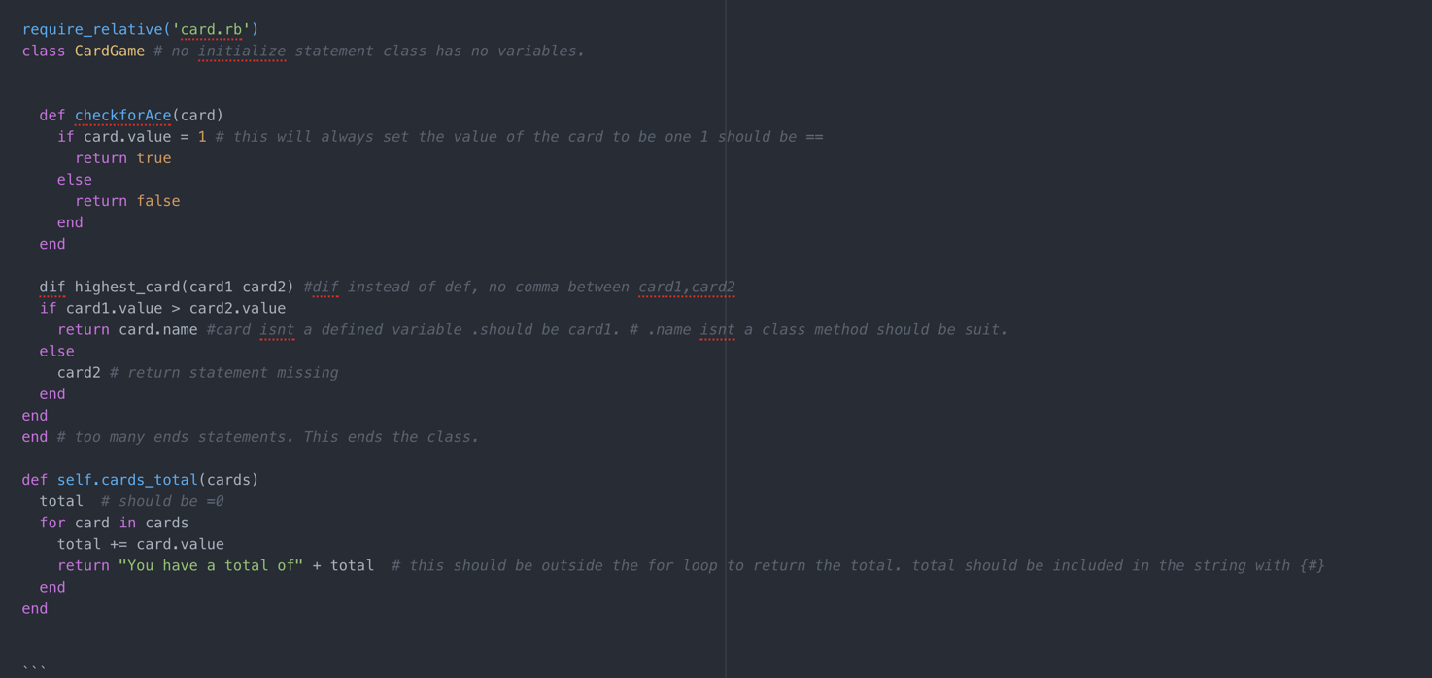

Figure 1- Test code

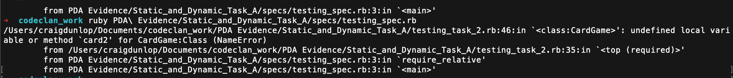

Figure 2- Test failing to run

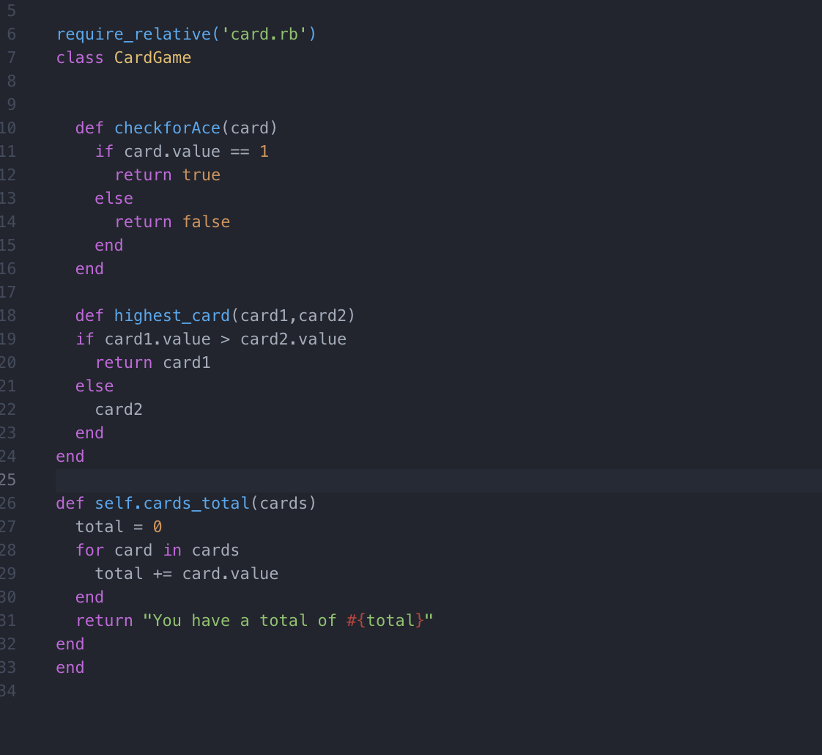

Figure 3-Corrected test code

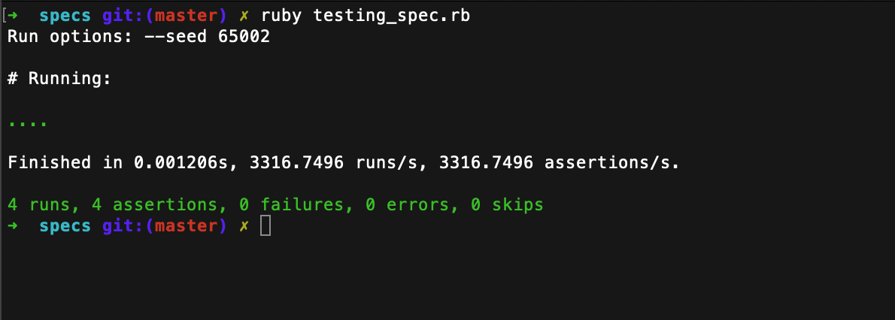

Figure 4-Tests passing

**Description here**

**Week 9**

| Unit | Ref | Evidence |  |
| --- | --- | --- | --- |
| P | P.1 | Take a screenshot of the contributor’s page on Github from your group project to show the team you worked with. | |
|  |  | **Description:** | |

**Paste Screenshot here**

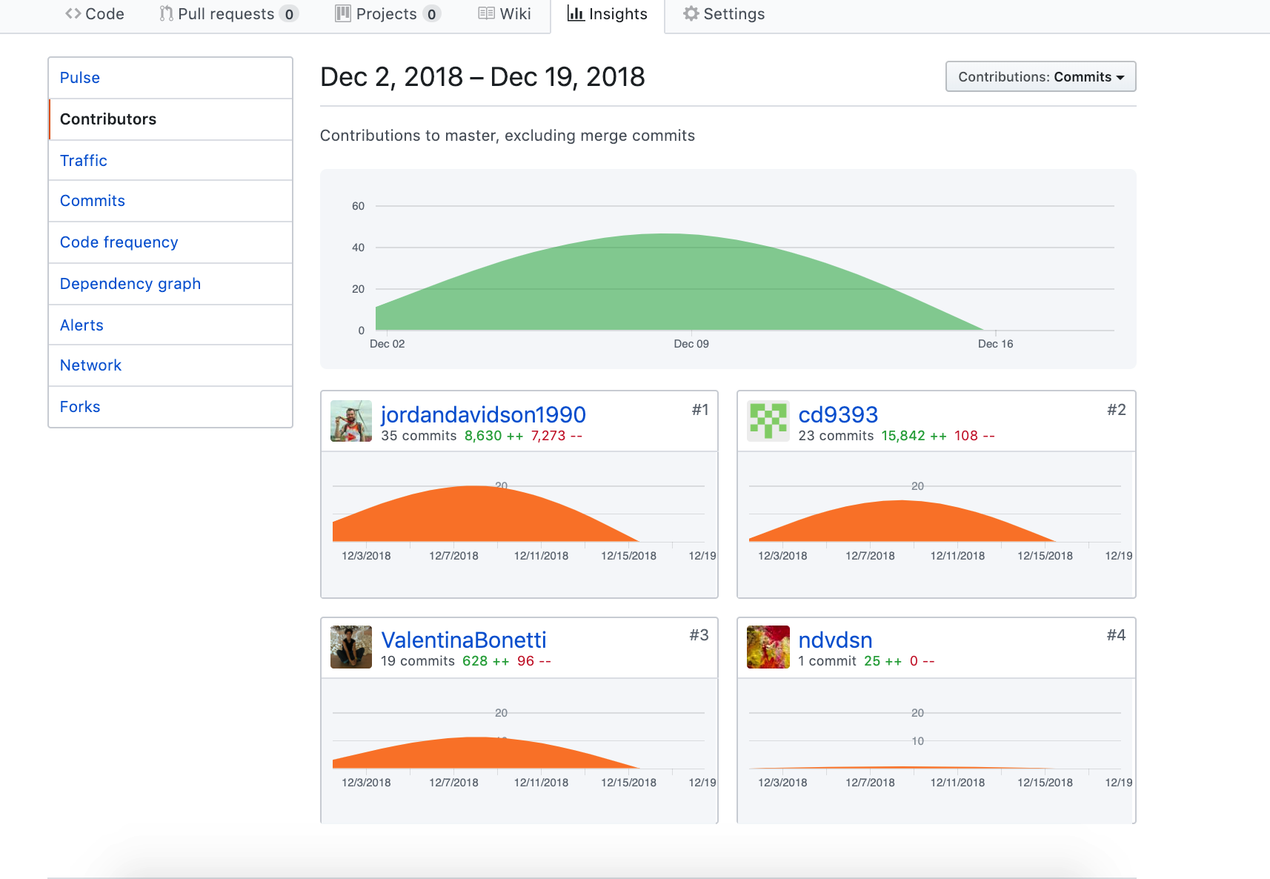

**Description here**

Contributors page from Group project.

| Unit | Ref | Evidence |  |
| --- | --- | --- | --- |
| P | P.2 | Take a screenshot of the project brief from your group project. | |
|  |  | **Description:** | |

**Paste Screenshot here**

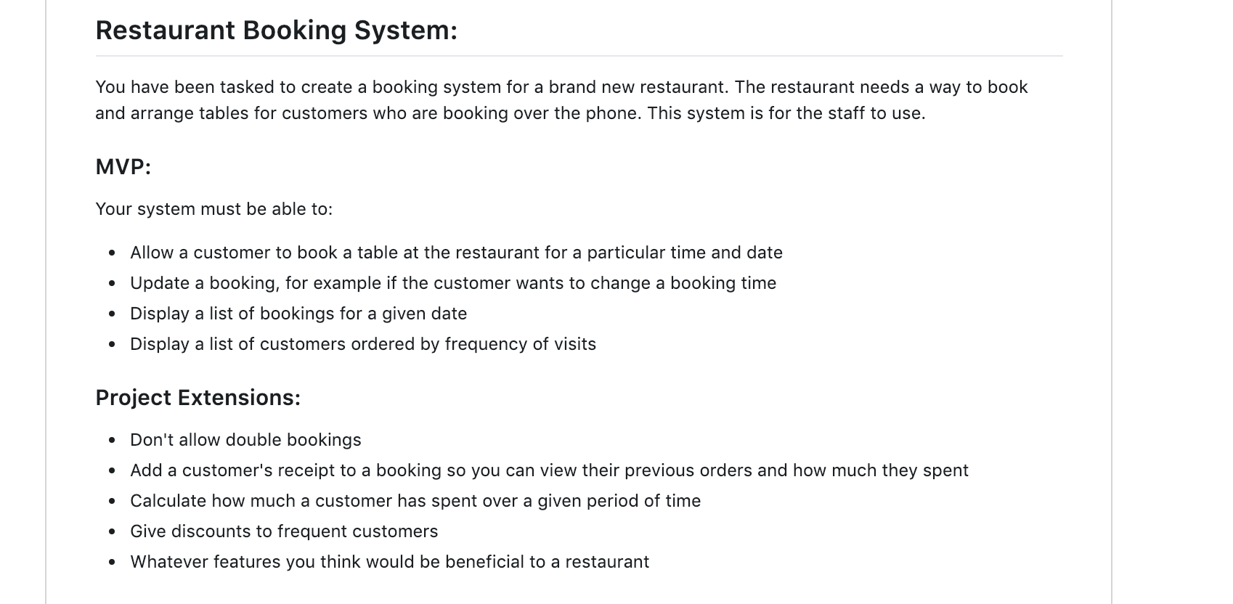

**Project Brief from Group Project**

| Unit | Ref | Evidence |  |
| --- | --- | --- | --- |
| P | P.3 | Provide a screenshot of the planning you completed during your group project, e.g. Trello MOSCOW board. | |
|  |  | **Description:** | |

**Paste Screenshot here**

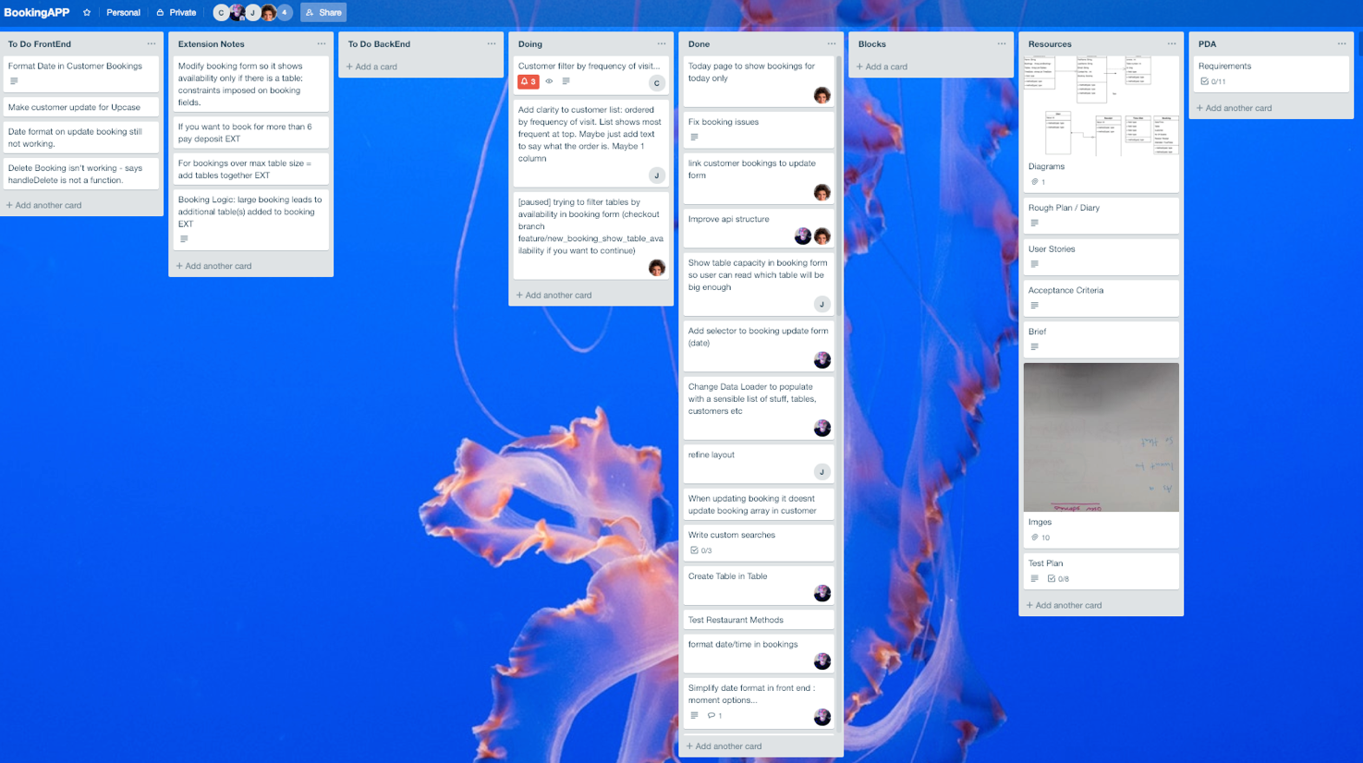

**Description here**

| Unit | Ref | Evidence |  |
| --- | --- | --- | --- |
| P | P.4 | Write an acceptance criteria and test plan. | |
|  |  |  | |

**Paste Screenshot here**

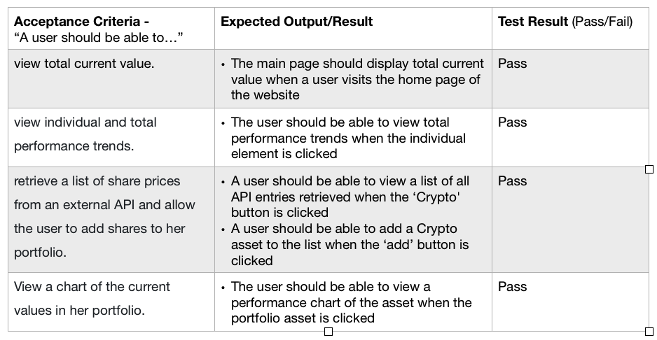

**Description here**

| Unit | Ref | Evidence |  |
| --- | --- | --- | --- |
| P | P.7 | Produce two system interaction diagrams (sequence and/or collaboration diagrams). | |
|  |  | **Description:** | |

**Paste Screenshot here**

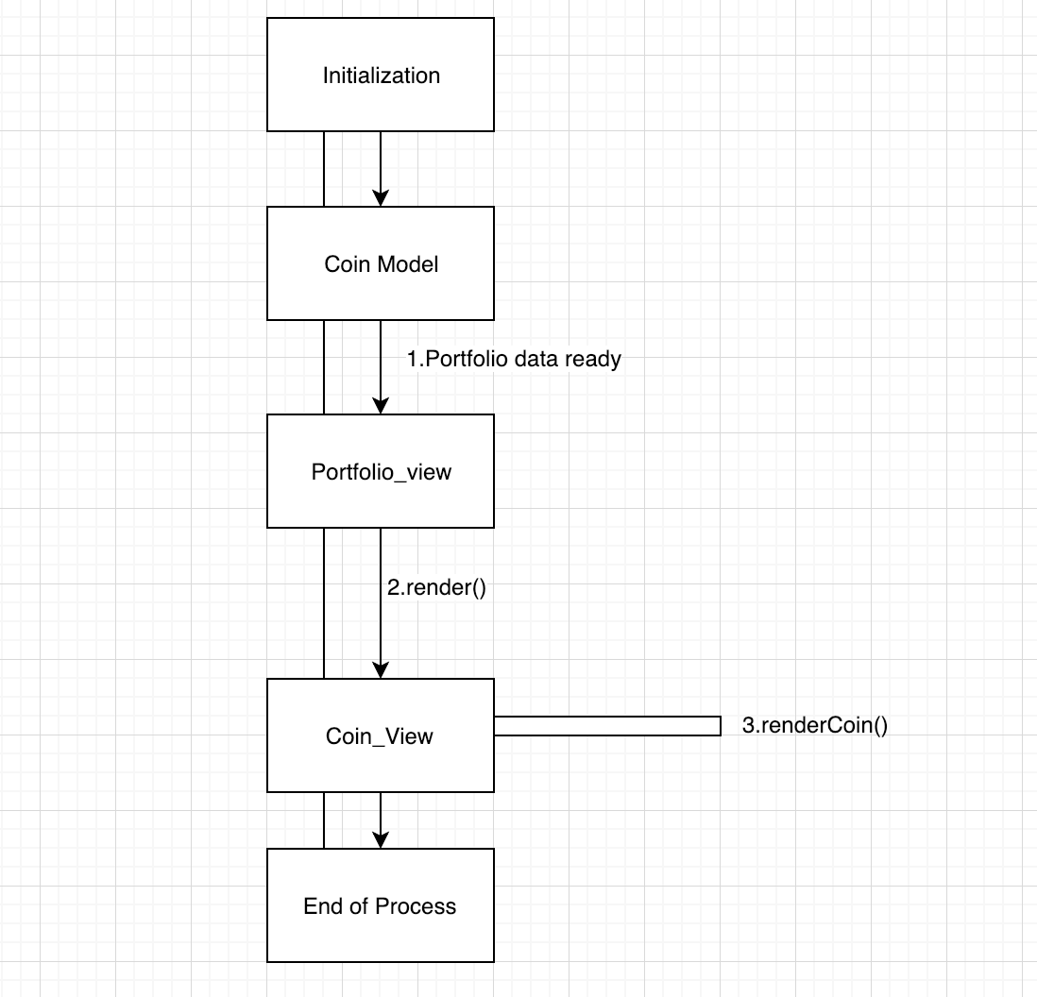

Figure 5-collaboration diagram to disply portfolio in cryptotracker

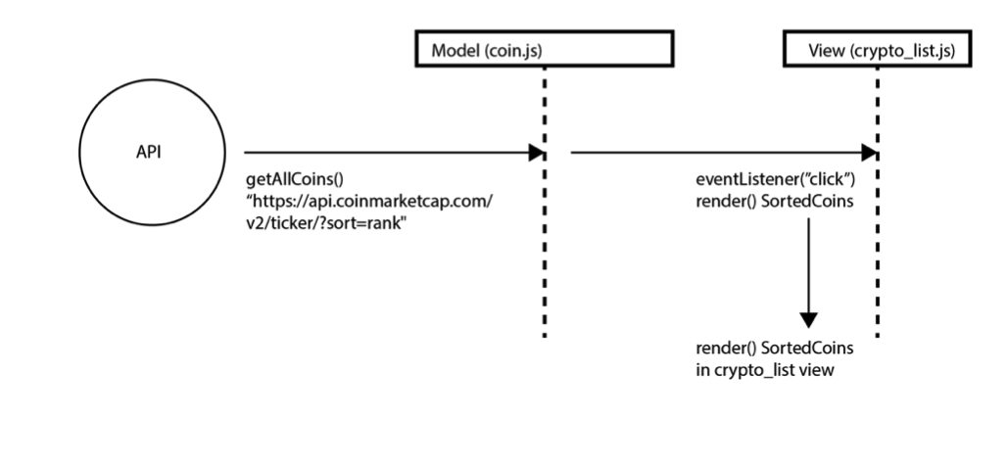

Figure 6-Sequence diagram to show how list of cryptocurrencies are rendered in cryptotracker

**Description here**

| Unit | Ref | Evidence |  |
| --- | --- | --- | --- |
| P | P.8 | Produce two object diagrams. | |
|  |  | **Description:** | |

**Paste Screenshot here**

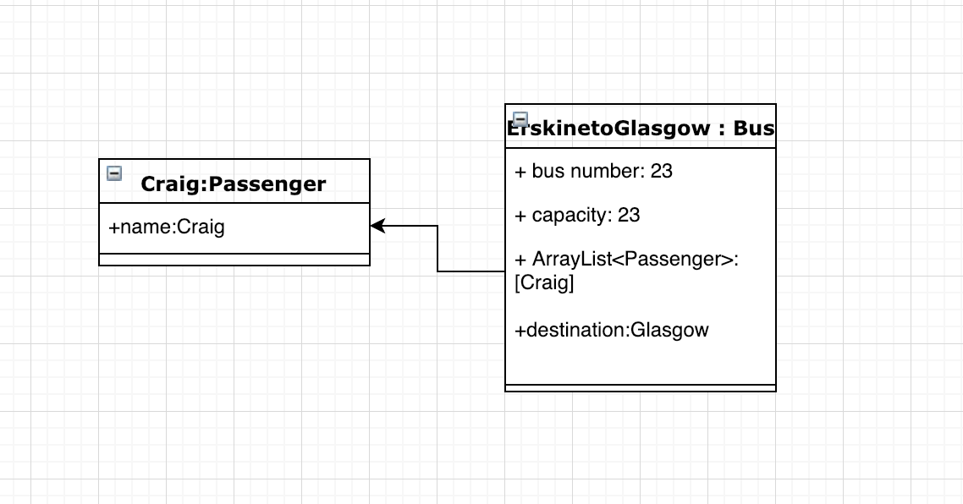

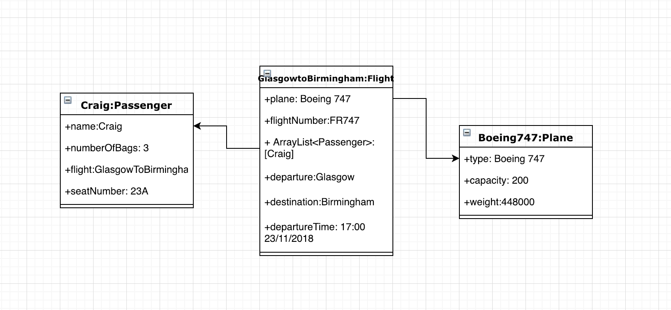

**Description here**

| Unit | Ref | Evidence |  |
| --- | --- | --- | --- |
| P | P.17 | Produce a bug tracking report | |
|  |  | **Description:** | |

**Paste Screenshot here**

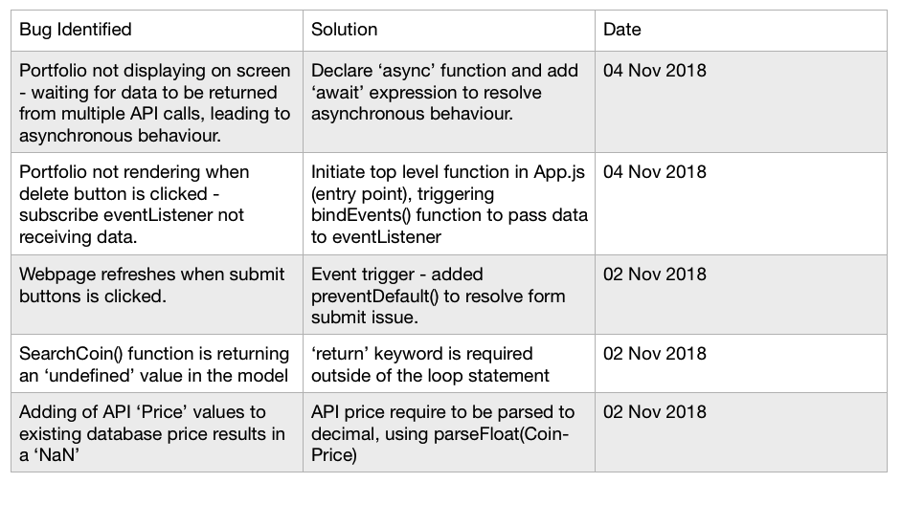

**Description here**

**Week 12**

| Unit | Ref | Evidence |  |
| --- | --- | --- | --- |
| I&T | I.T.7 | The use of Polymorphism in a program and what it is doing. | |
|  |  | **Description**: | |

**Paste Screenshot here**

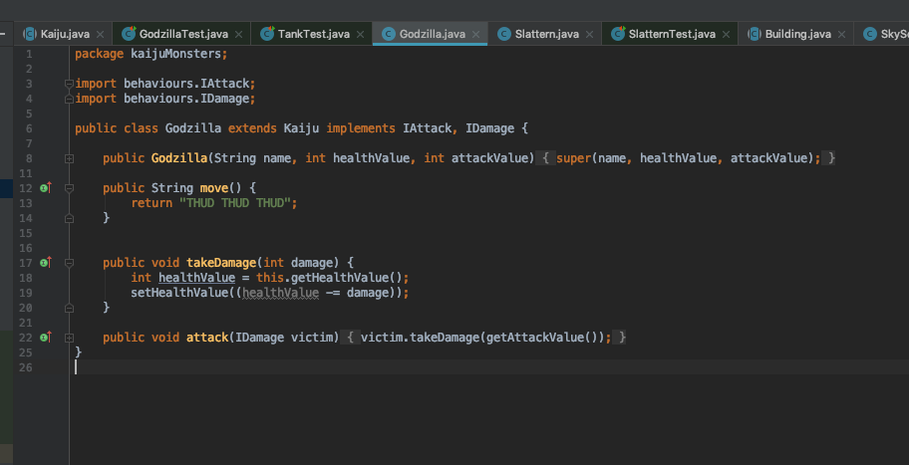

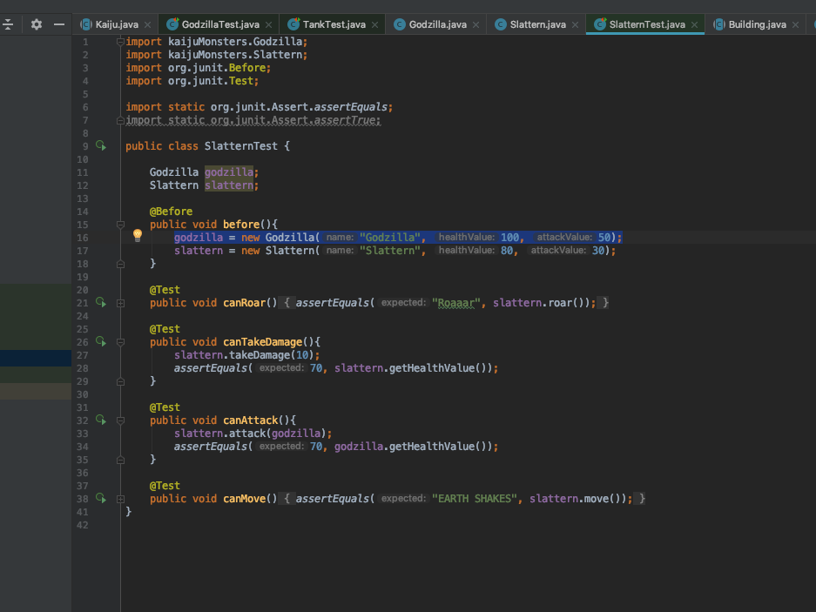

**Description here**

Godzilla is A Kaiju, Godzilla, IAttack and IDamage. The attack method takes in an IAttack type . As the Godzilla implements the IAttack interface it is able to be passed into the attack method.

| Unit | Ref | Evidence |  |
| --- | --- | --- | --- |
| A&D | A.D.5 | An Inheritance Diagram | |
|  |  | **Description:** | |

**Paste Screenshot here**

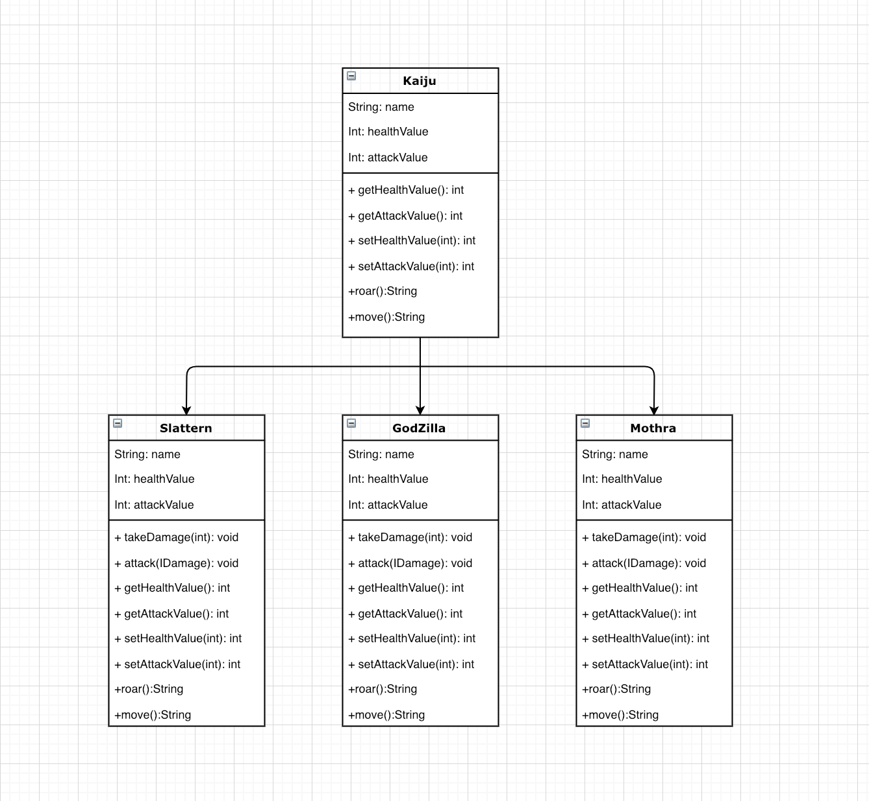

**Description here**

| Unit | Ref | Evidence |  |
| --- | --- | --- | --- |
| I&T | I.T.1 | The use of Encapsulation in a program and what it is doing. | |
|  |  | **Description:** | |

**Paste Screenshot here**

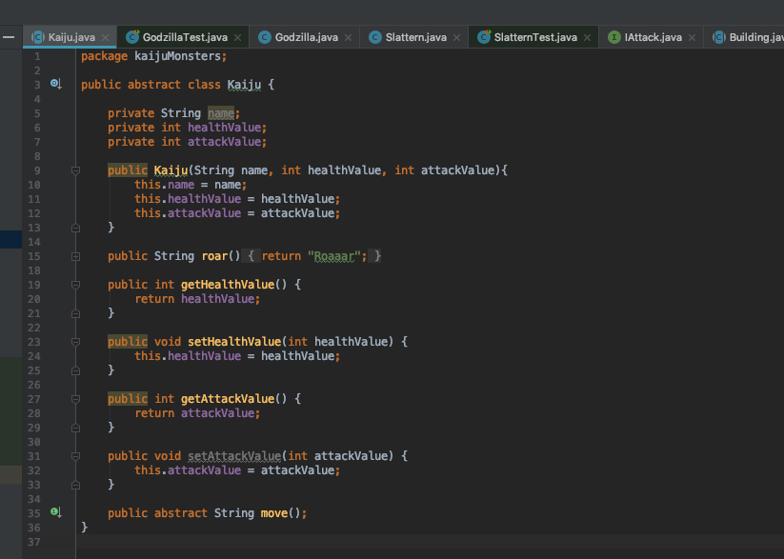

**Description here**

declaring variables as private to prevent it being accessed by other classes and writing public methods in order to access and edit the variables.

| Unit | Ref | Evidence |  |
| --- | --- | --- | --- |
| I&T | I.T.2 | Take a screenshot of the use of Inheritance in a program. Take screenshots of:  *A Class  *A Class that inherits from the previous class  *An Object in the inherited class  *A Method that uses the information inherited from another class. | |
|  |  | **Description:** | |

**Paste Screenshot here**



Figure 7- A Class



Figure 8- Godzilla class inherits from kaiju

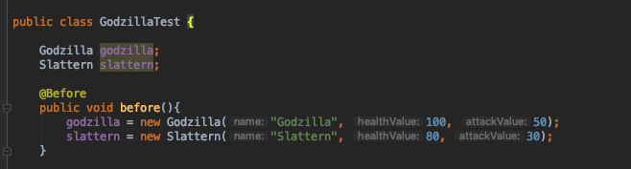

Figure 9- Godzilla object

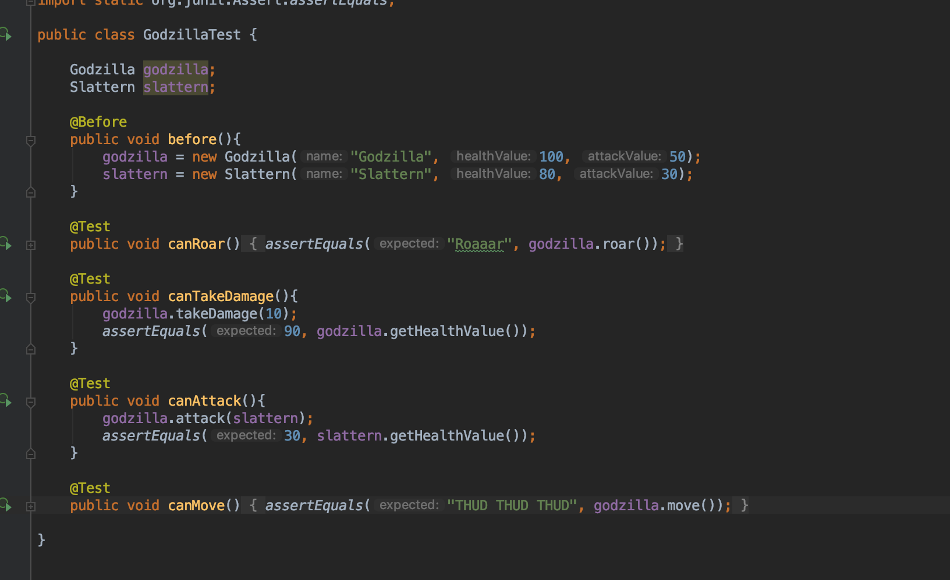

Figure 10- method using information inherited from another class

**Description here**

| Unit | Ref | Evidence |  |
| --- | --- | --- | --- |
| P | P.9 | Select two algorithms you have written (NOT the group project). Take a screenshot of each and write a short statement on why you have chosen to use those algorithms. | |
|  |  | **Description:** | |

**Paste Screenshot here**

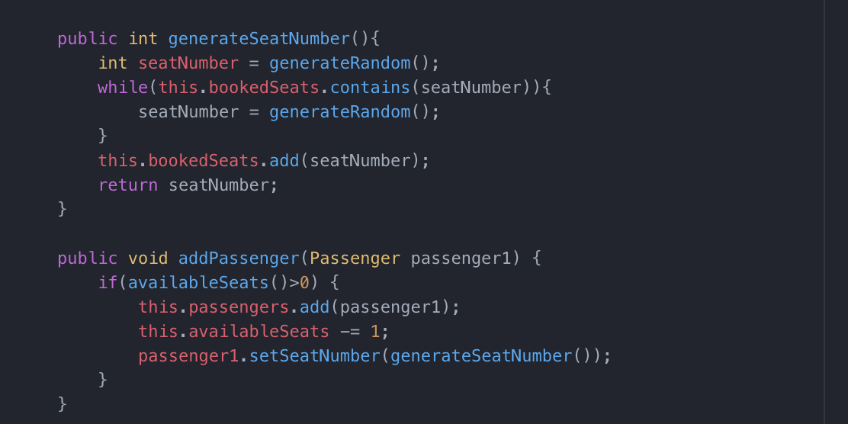

**Generate Seat number function will assign the seat number a random number and then will run a while loop to check whether the seat number already exists in the booked seats array, if it does then it will assign a new random number and repeat the while loop until it assigns a number which doesn’t exist in the booked seats array and then add this to the booked seats array and return the seat number.**



**This function combines the information from two different API requests. It initially creates an object for the real time information for the coin and then does another API request to create the historic pricing data of the coin. It will then push the real-time information to the start of the array list and publish it out.**

**Description here**